# ACKNOWLEDGEMENT

We would like to express our deepest sense of gratitude and sincere thanks to our respected guide **Mr. Jenish Lavji** for his valuable guidance, constructive suggestions during the design and implementation of this project. His constant support and encouragement are sincerely appreciated.

Further, we are grateful to **Ms. Purvi Tandel**, Head of the Department, Information Technology, CGPIT for giving us the opportunity to undertake this project.

Also, we are very thankful to our Director Dr. Rajkumar Patil for providing us excellent environment to work in.

We appreciate all the faculty members for their patience, understanding and guidance that gave us strength and will power to work on this project and preparing the report.

Finally, we wish to thank our family and friends who showed their support and encouragement throughout our project as well as studies.

**Karan Bhatt (201803100810008)**

**Kevin Mehta (201803100810074)**

# 

# ABSTRACT

Reading books is considered as one of the best hobbies one could have. Number of people reading books are increasing exponentially today. Books are sometimes really expensive and not everybody is willing or able to pay. For this, traditional system of exchanging books is solution but it is not an efficient in today’s world. It is a hectic process to find someone or some shop that are willing for the exchange. Therefore, a better solution is to build a platform through which people can exchange books with each other by just accessing the platform through internet with ease. This process is not time consuming like traditional way as this will not take hours to find what you are looking for instead it will just take seconds to do the same task.

**TABLE OF CONTENTS**

ACKNOWLEDGEMENT iii

ABSTRACT iv

LIST OF FIGURES vii

Chapter 1 Introduction 1

1.1 Background 1

1.2 Problem Definition 1

1.3 Motivation 1

1.4 Objective 1

1.5 Scope 1

1.6 Applications 2

Chapter 2 System Planning 3

2.1 Project Development Approach 3

2.2 System Modules 4

2.2.1 Authentication………………………………………………………………. …4

2.2.2 Homepage 4

2.2.3 Inbox 4

2.2.4 Feed 4

2.2.4 User Dashboard…………………………………………………………………..5

2.2.5 Admin Panel ………………………………………………………….…………5

2.3 Functional Requirements 5

2.4 Non Functional Requirements 6

2.5 Hardware and Software Requirements 6

2.6 Timeline Chart 7

Chapter 3 System Design 8

3.1 Use Case Diagram 9

3.2 Sequence Diagram 10

3.3 Activity Diagram 11

3.4 Class Diagram 12

3.5 Data Flow Diagram Diagram 12

Chapter 4 Implementation and Testing 14

4.1 Snapshots 14

4.2 Test Cases 28

Conclusion and Future Scope 30

References 31

# LIST OF FIGURES

Figure 2.1: Timeline Chart………………………………………………………………….7

Figure 3.1: Database Schema……………………………………………………………….8

Figure 3.2: Use Case Diagram...…………………………………………………………….9

Figure 3.3: Sequence Diagram..………………………………...…………………………10

Figure 3.4: Activity Diagram…….…………………………………...…………………...11

Figure 3.5: Class Diagram……….………………………………………………………...12

Figure 3.6.1: Data Flow Diagram Level-0……………..…………………………...……...12

Figure 3.6.2: Data Flow Diagram Level-1……………..…………………………...……...13

Figure 4.1: Home Page Before Login……………..…………………………………….....14

Figure 4.2: Home Page After Login..……………..…………………………………….....14

Figure 4.3: Mobile View….…………..…………..…………………………………….....15

Figure 4.4: Register Page……………..…………..…………………………………….....15

Figure 4.5: Login Page………………..…………..…………………………………….....16

Figure 4.6: Profile Page………………..…………..……………………………………....16

Figure 4.7: Profile Updation…………..…………..…………………………………….....17

Figure 4.8: Uploading Post…..………..…………..…………………………………….....17

Figure 4.9: After Post Uploaded…..…..…………..…………………………………….....18

Figure 4.10: Commenting on post.………………..…………………………………….....18

Figure 4.11: After Comment……...………..…………..……………………………….....19

Figure 4.12: Add Friend…...……...………..…………..……………………………….....19

Figure 4.13: Sending Friend Request..……..…………..……………………………….....20

Figure 4.14: Received Friend Request.……..…………..……………………………….....20

Figure 4.15: Friend List…………...………..…………..……………………………….....21

Figure 4.16: Selecting User for Conversation…………..……………………………….....21

Figure 4.17: Begin the Conversation ……...………..…………..………………………...22

Figure 4.18: Inbox………………...………..…………..……………………………….....22

Figure 4.19: Admin Panel Login.....………..…………..……………………………….....23

Figure 4.20: Admin Panel………...………..…………..……………………………….....23

Figure 4.21: Admin Profiles……...………..…………..…………………………….….....24

Figure 4.22: Users………...……...………..…………..………………………………......24

Figure 4.23.1: User Likes………...………..…………..…………………………….….....25

Figure 4.23.2: Removing User Likes…….....…………..……………………………….....25

Figure 4.24.1: User Comments…...………..…………..…………………………….….....26

Figure 4.24.2: Removing User Comments....…………..……………………………….....26

Figure 4.25.1: User Posts………...………..…………..…………………………….….....27

Figure 4.25.2: Removing User Posts……..…………..……...………………………….....27

# Chapter 1 Introduction

## 1.1 Background

This will allow users to exchange books with those who are willing to do the same. It will mitigate the time consuming activities that were found in traditional way of book exchange process. That process involves users to perform tasks that are not feasible today. However, that won’t be the case with this platform. Users just need to enter some details on the platform and its done.

## 1.2 Problem Definition

Many individuals want to sell the books they no longer need. Traditionally, they can either talk to their friends or sell the books back to the bookstore for a tiny sum or can exchange with other books. These activities are time-consuming and garner little revenue. It is the goal of the system to bring those people together who want to sell or exchange the books and simplify the process.

## 1.3 Motivation

## Motivation behind this topic is to provide free literacy and education in the society. With the help of this platform the people with low income and with real needs can get benefited. In today’s time the cost to produce a single books has increased and also a large number of trees are shredded for it, so this platform will help to overcome those problems.

## 1.4 Objective

The overall objective is to develop a platform for book exchange. The aim is to provide a single platform to those users who do not want to spend or do not have sufficient amount of money to spend on books. This website will provide an inexpensive way for such people to exchange books, find out about new books and obtain a new book to read.

## 1.5 Scope

The website hopes to have an audience who are in search of books. Anyone can access the platform. Person who already have fond of reading or who want to begin to read the books can access.

Someone who intends to sell the books or someone who wants to explore and buy books provided on the webs are also welcomed on the platform.

## 1.6 Applications

This project is aimed at developing system which will be helpful to automatically detect students attending a lecture in a classroom and mark their attendance by recognizing their faces. Use of the face detection and recognition system will provide a fast and effective method of capturing student attendance accurately while offering a secure, stable and robust storage of the system records. Further applications- To Access Control in Offices, searching for lost people etc.

# Chapter 2 System Planning

## 2.1 Project Development Approach

Each project need to be developed with software model which makes the project with high quality, reliable and cost effective.

* **Name of the software model** Incremental Model
* **Explaination**
* Incremental Model is a process of software development where requirements are broken down into multiple standalone modules of software development cycle. Incremental development is done in steps from analysis design, implementation, testing/verification, maintenance.
* Each iteration passes through the requirements, design, coding and testing phases. And each subsequent release of the system adds function to the previous release until all designed functionality has been implemented.

Characteristics of an Incremental module includes:

* System development is broken down into many mini development projects
* Partial systems are successively built to produce a final total system
* Highest priority requirement is tackled first

• **Justification**

* As the characteristics mentioned above, our project is broken into different modules like face detection and face recognition which can be developed independently.
* Thus those modules were built parallely and seperately with testing the accuracy of individual modules and then performing integration.
* As these modules can be tested individually making changes is easy and development also gets fast.
* The first incremental model consist of capturing image and detecting and recognizing faces with some accuracy
* The second incremental version consists of entering few details about class and generating excel sheet for attendance of class.

• **Advantages**

* The software will be generated quickly during the software life cycle
* It is flexible and less expensive to change requirements and scope
* Throught the development stages changes can be done
* Errors are easy to be identified

## 2.2 System Modules

The below mentioned modules are included in the entire project.

### 2.2.1 Authentication

The primary role of this module is to authenticate users who are accessing the platform. It is necessary so that anyone who is not authenticated cannot access the platform. Here the new users can register whereas existing users can login and logout.

### 2.2.2 Homepage

This module will let users to upload or save the posts, search the books directly by entering the book name or can select different genres.

### 2.2.3 Inbox

The primary goal of this module is to allow users to send and receive messages to each other. This can be performed once both users are in each other’s friends list.

### 2.2.4 Feed

In this module, user is able to view the posts uploaded by the other users. The entire feed is generated based upon the posts uploaded by different users. Feed is unique for every users. Also. User can like and comment on the posts.

### 2.2.4 User Dashboard

This module is unique for every users. Her users are able to view their profile and could update it. Number of followers along with the posts they have uploaded can be viewed. If there are any friend request that is also displayed over here.

### 2.2.5 Admin Panel

This module can only be accessed by Admin. Admin manages all the user related details their posts, followers, profile and much more along with the database. Admin is the highest authority.

## 2.3 Functional Requirements

|  |  |
| --- | --- |
| **ID** | **Title & Description** |
| FR1 | Title:Signup  Desc: New users will have to register to use the website. |
| FR2 | Title:Login  Desc:Registered users are able to log on to the website. |
| FR3 | Title: Home  Desc: On the homepage the general layout along with features such as filter, search, post, DMs and many more will be offered. |
| FR4 | Title: About  Desc: On this page, the information regarding the website and their makers are provided. |
| FR5 | Title: User Dashboard  Desc: Users will be able to see their profile, followers, and their posts. They can also update, delete their posts as well as certain information in this section. |
| FR6 | Title: Admin Dashboard  Desc: In this section, only the admin can enter and can remove users, posts, and inappropriate information across the website. |
| FR7 | Title: Contact  Desc: Here, information about contacting the website makers is given. |

## 2.4 Non Functional Requirements

* Security: User credentials details are safe which comes from users or from cookies to the database. Prevents malware attacks.
* Performance: The website will load smoothly and in a fast manner.
* Portability: A website can be accessed from any computing device with the internet.
* Availability: Website will be available 24x7 and in case of any failure of hardware, database corruption backups of the database should be retrieved from the server.
* Scalability: If demands of these user increases website would be capable to handle it and remain stable.
* Reliability: If any problem or situation arises then still site can run without failure of the system or elements.
* Regularity: A website should be updated regularly to improve and give the user the best interface.
* Storage: User Information is stored in a database so that it can be easily retrieved whenever needed.
* Access: Only authorized users can enter into the admin dashboard by proving his/her authentication using the correct username and password.
* Understandability: The website interface should be less complex as it includes more categories so users can understand easily.

## 2.5 Hardware and Software Requirements

**Hardware Requirements:**

* Processor: Dual-core i3 or more
* RAM: 2 GB
* Hard Disk: 10 GB

**Software Requirements:**

* OS: Windows/Ubuntu/MacOs
* Browser: Google chrome/Microsoft Edge/ Mozilla Firefox or any other.

## 2.6 Timeline Chart

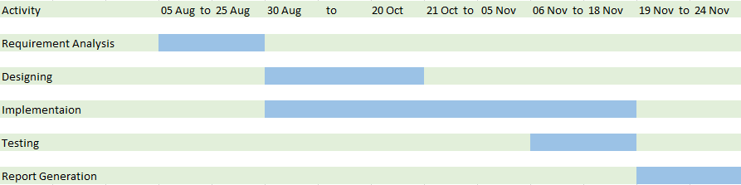

# Chapter 3 System Design

## 3.1 Database Schema

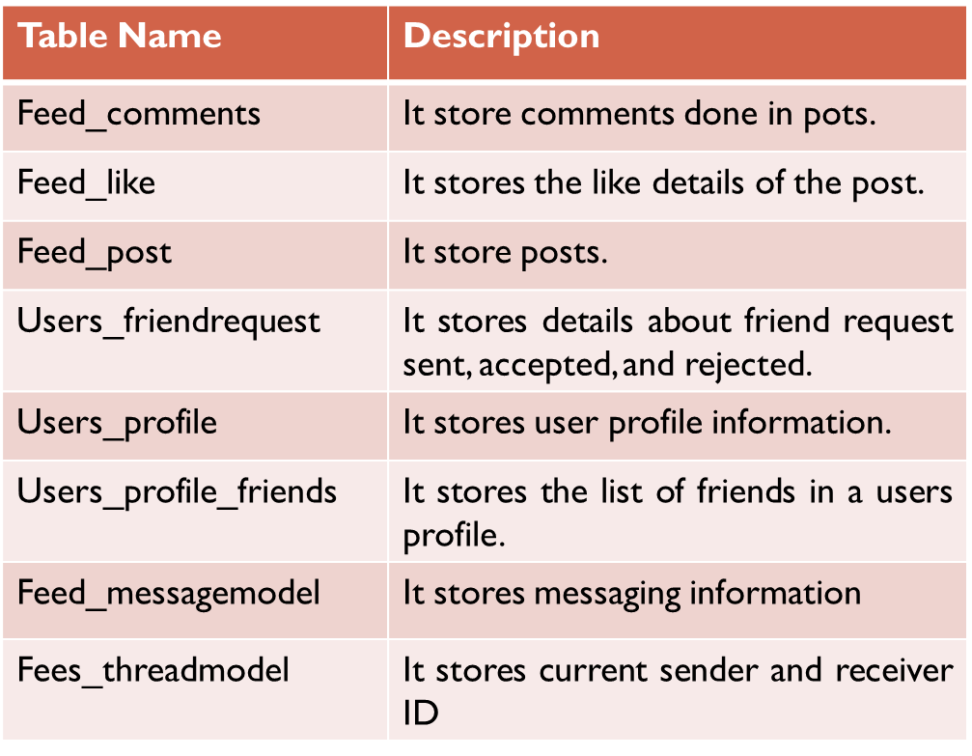

Fig 3.1: Database Schema

## 3.2 Use Case Diagram

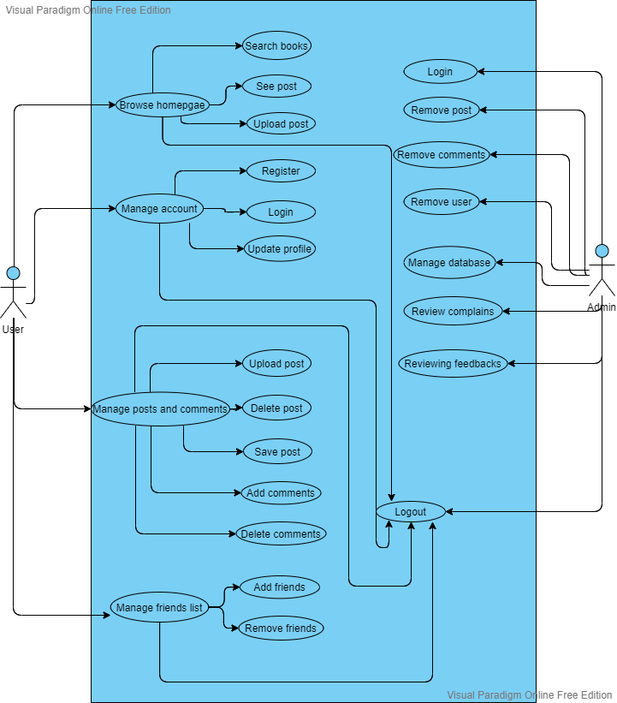

Fig: 3.2 Use case Diagram

**3.3 Sequence Diagram**

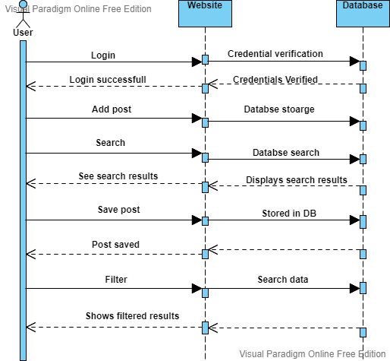

#### Fig 3.3: Sequence Diagram

## 3.4 Activity Diagram

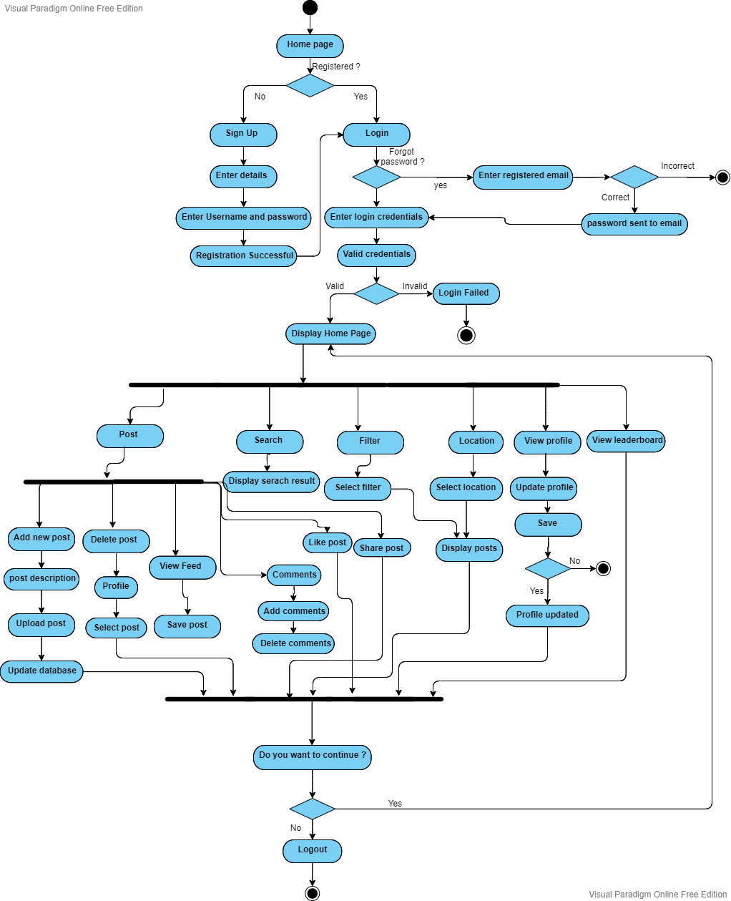Fig 3.4: Activity Diagram

## 3.5 Class Diagram

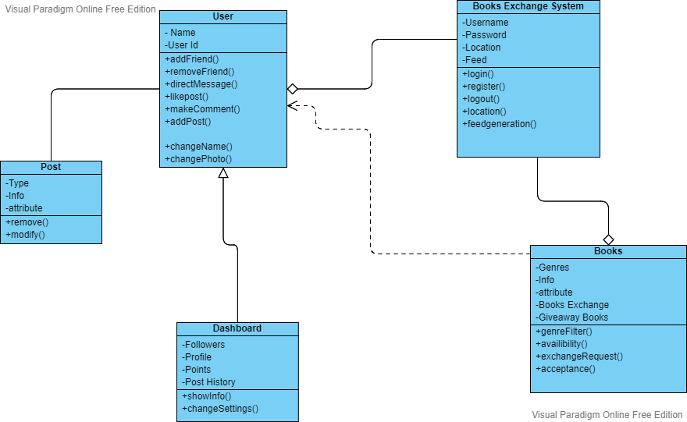

Fig 3.5: Class Diagram

## 3.6 Data Flow Diagram

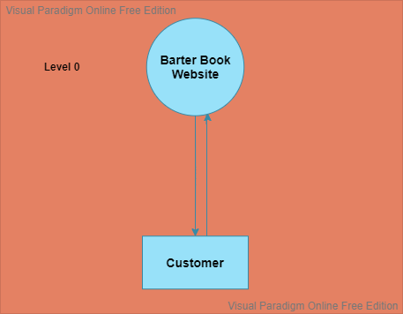

Fig 3.6.1: DFD Level-0

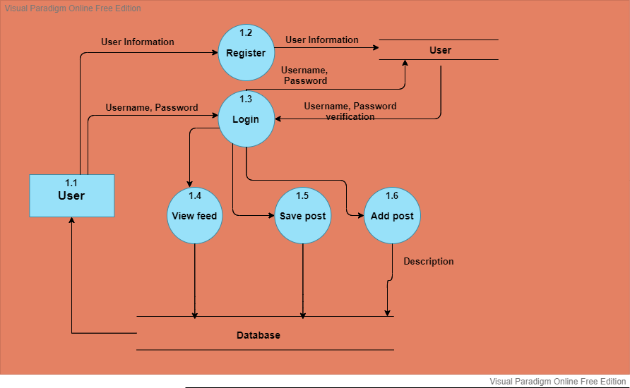

Fig 3.6.2: DFD Level-1

# 

# Chapter 4 Implementation and Testing

## 4.1 Snapshots

* **Home Page**

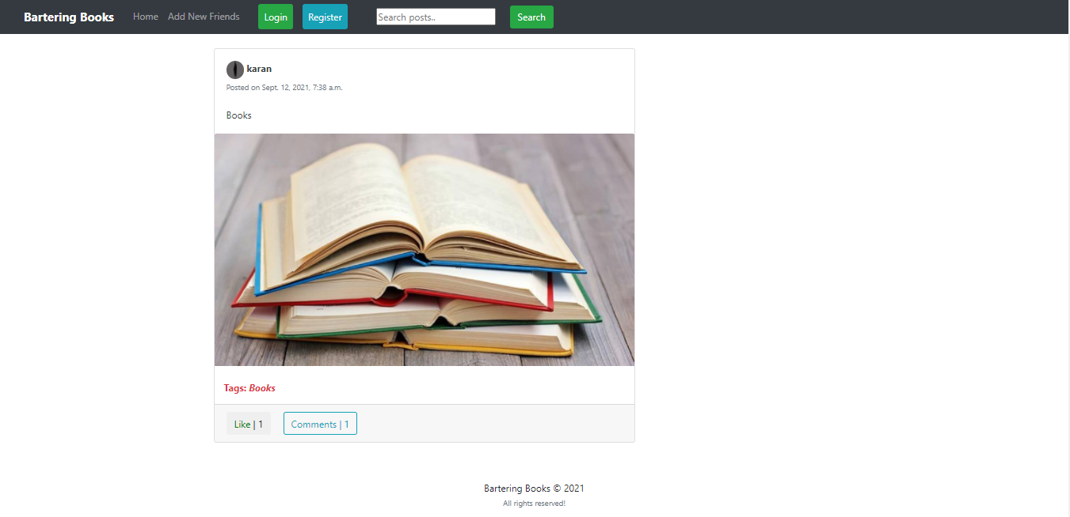

Figure 4.1: Home Page before login

This is layout of the homepage before login.

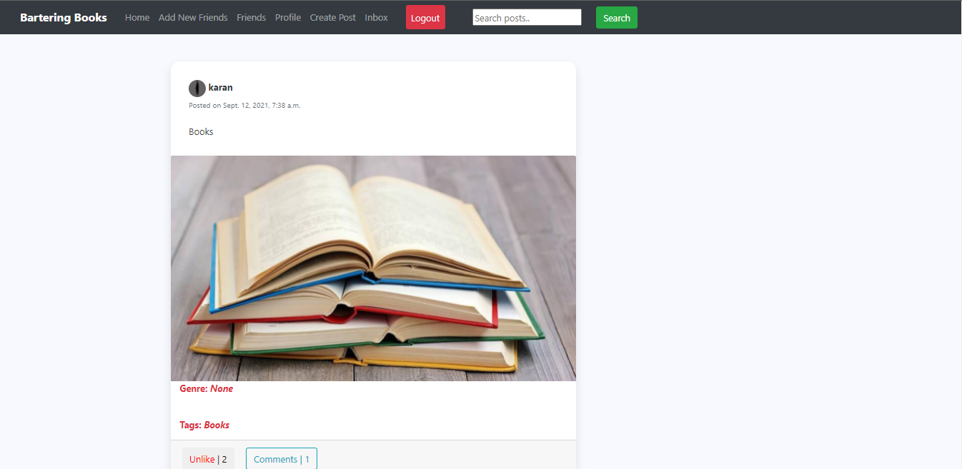

Fig 4.2: Home Page after login

This layout is visible to user after login.

* **Mobile View**

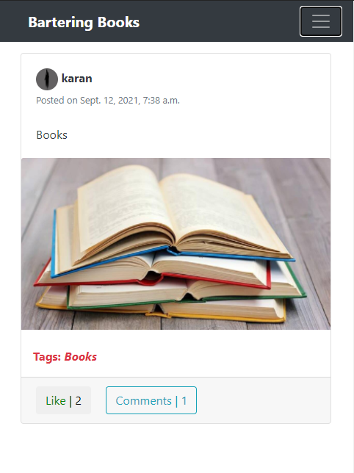 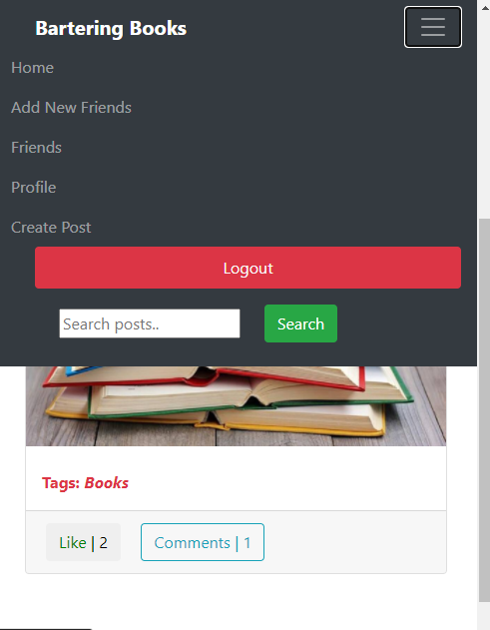

Figure 4.3: Mobile View

This is how website looks when opened in mobile.

* **Register**

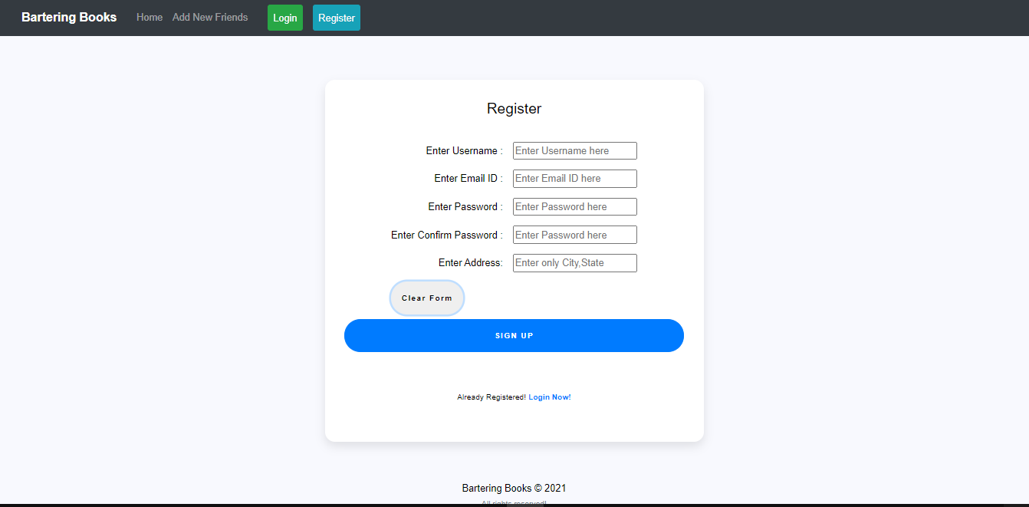

## Figure 4.4: Register Page

This page shows the sign up form that user needs to fill when visiting the website for the first time.

* **Login**

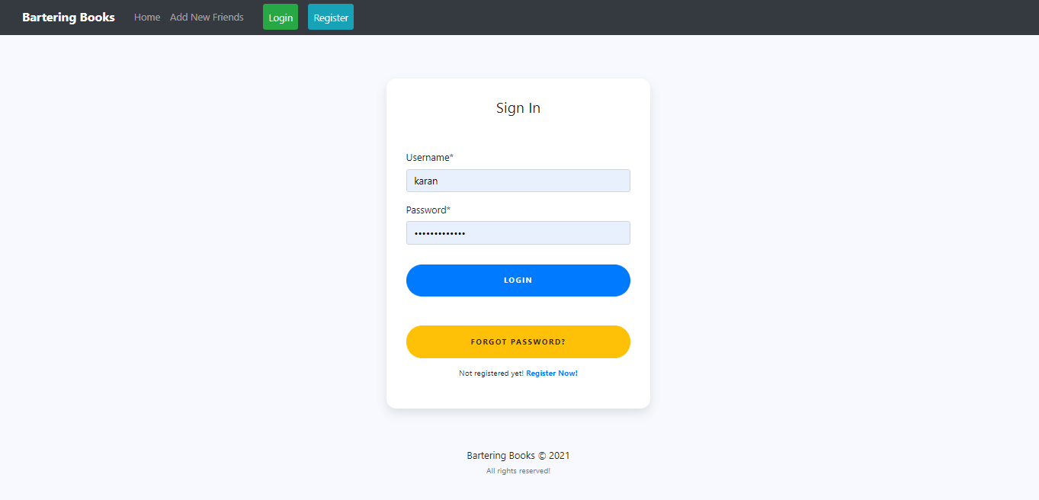

Figure 4.5: Login Page

This is the login page where user is required to enter credential details in order to login.

* **Profile**

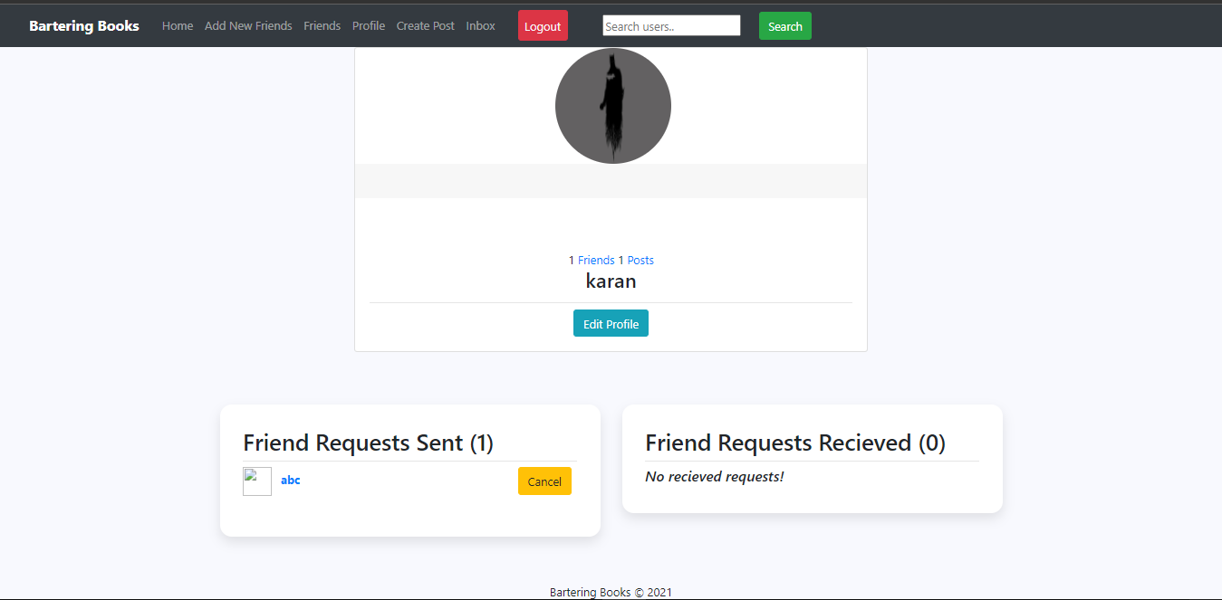

#### Figure 4.6: Profile Page

This is profile page of user where their username, friends, followers and friend request is visible.

* **Profile Update**

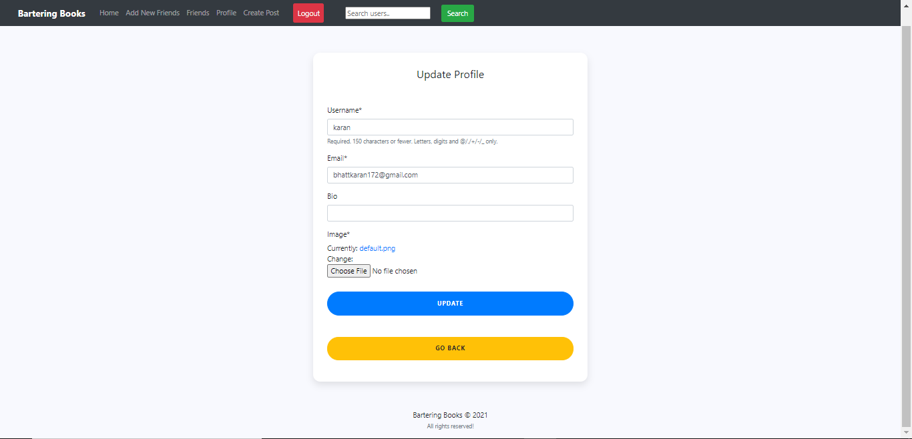

Fig 4.7: Profile Update

This page shows the information that can be updated by the user in their respective profile section.

* **Upload Post**

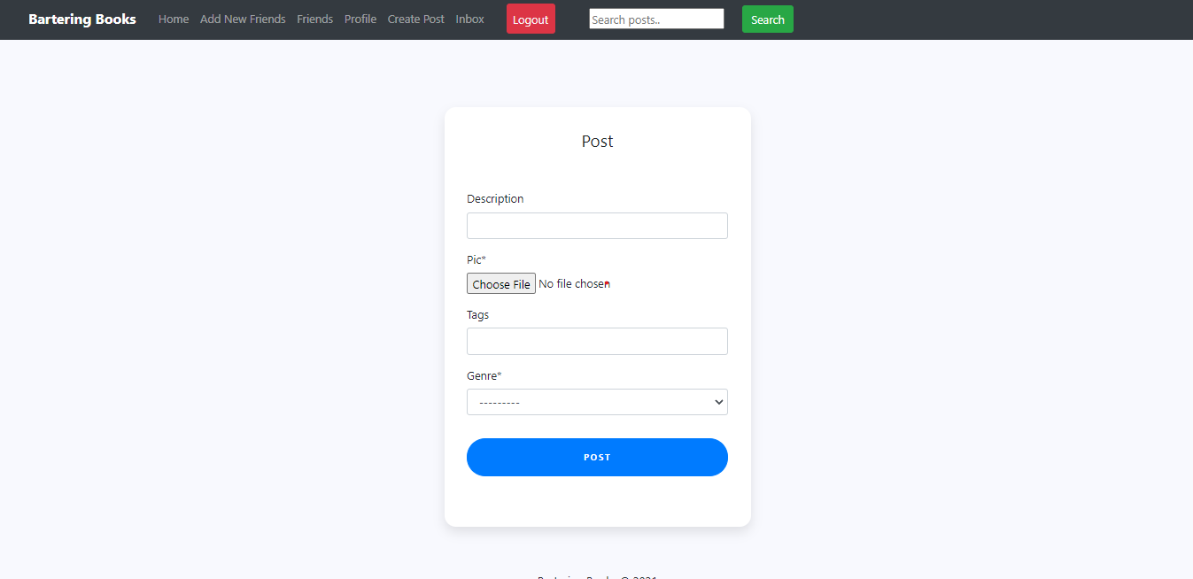

Fig 4.8: Uploading Post

Here, the shown details are supposed to be entered by the user when uploading the post.

* **Post Uploaded**

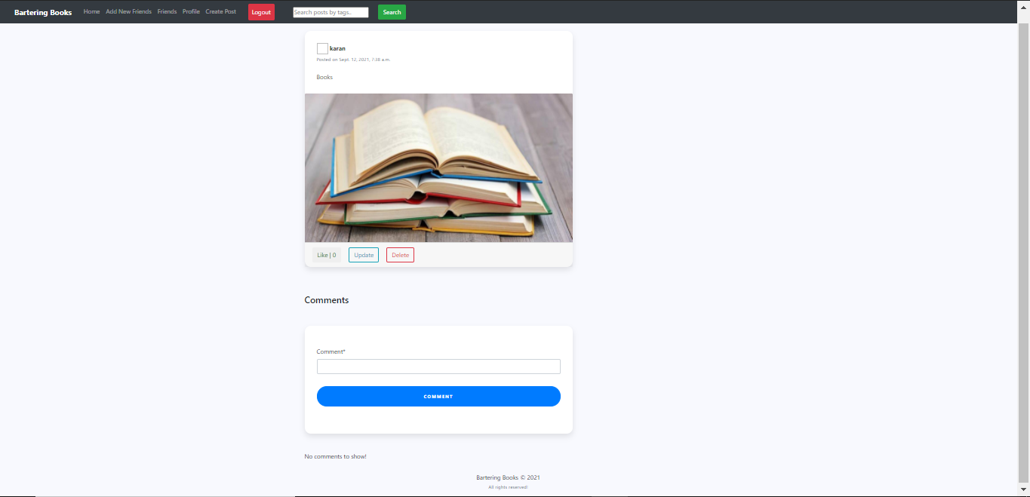

Fig 4.9: After post is uploaded

This page shows the layout after the post is uploaded by the user.

* **Comments**

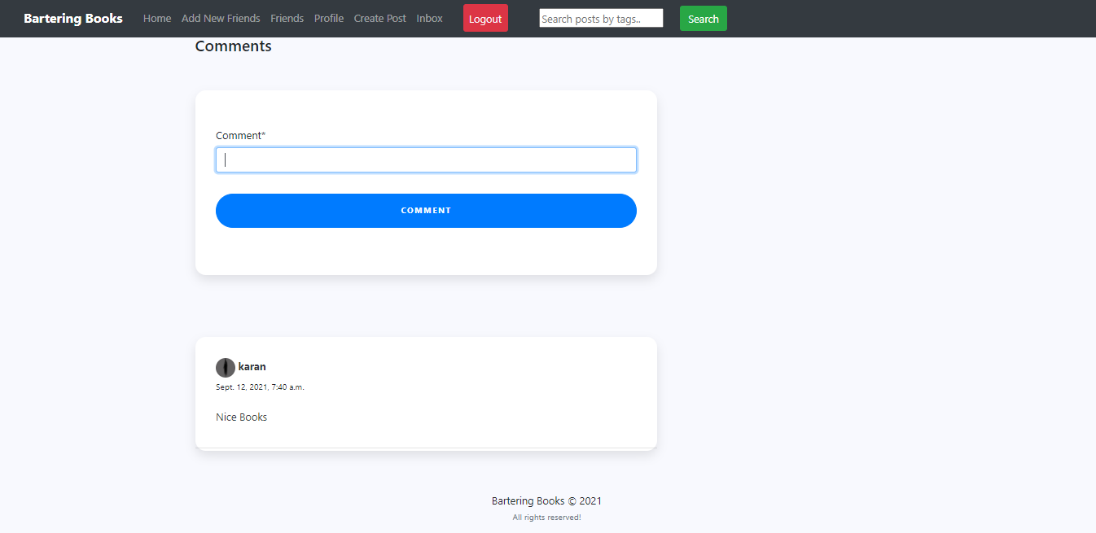

Fig 4.10: Commenting on post

This page shows the comment section where user can make comments on the post.

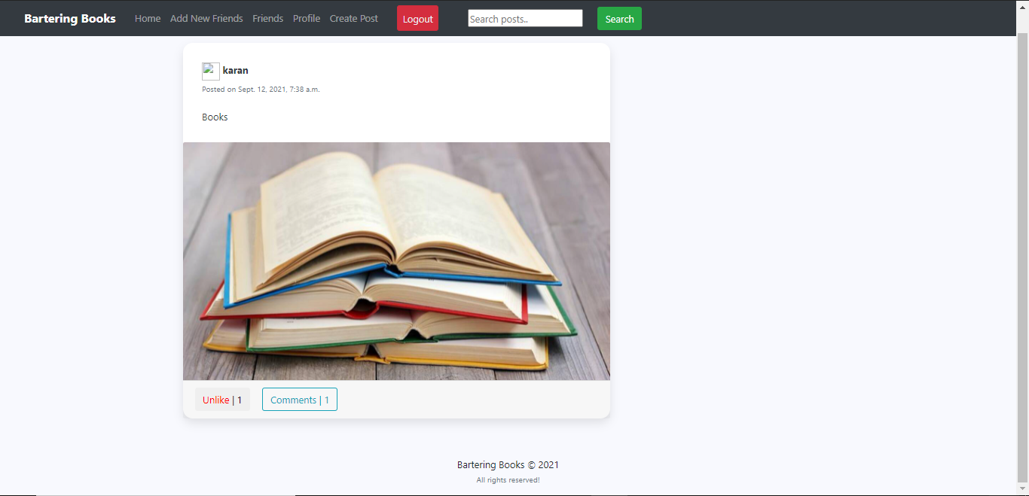

Fig 4.11: After Comment

This picture shows the post on which a comment has been made.

* **Add Friends**

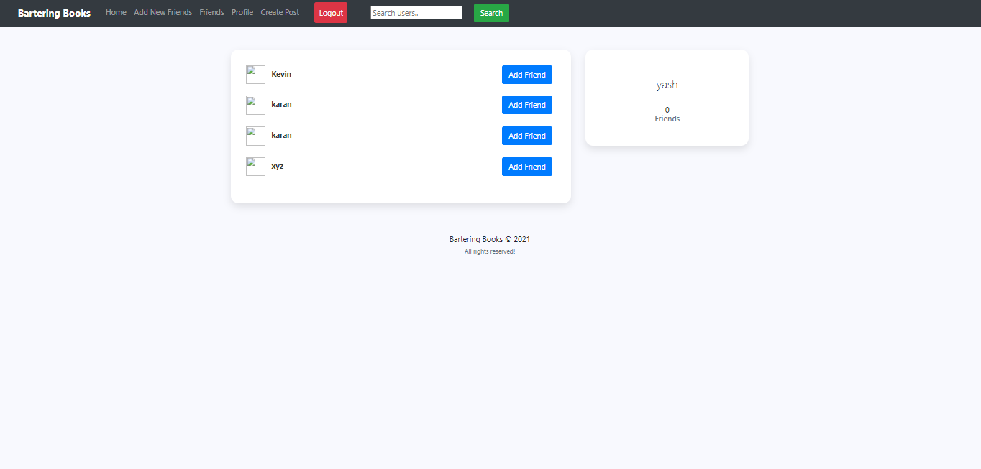

Fig 4.12: Add Friend

This section allows user to add friends and can connect with them.

* **Friend requests**

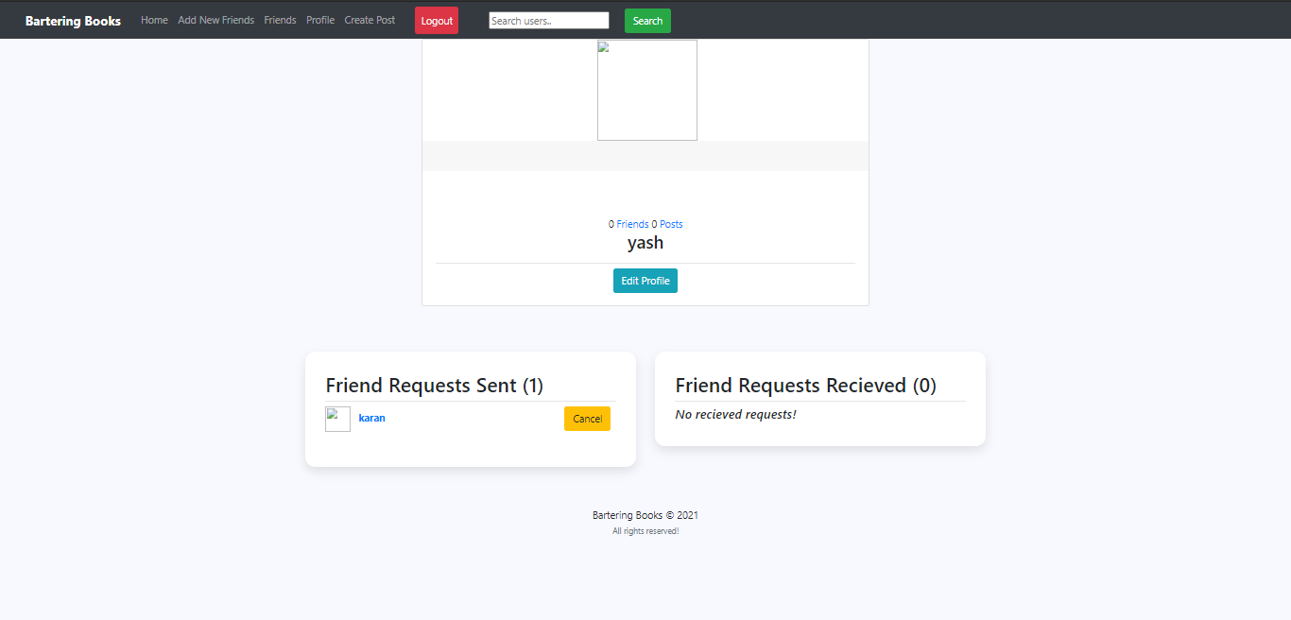

Fig 4.13: Sending Friend Request

Users could send a friend request from add friend section which was shown in previous picture.

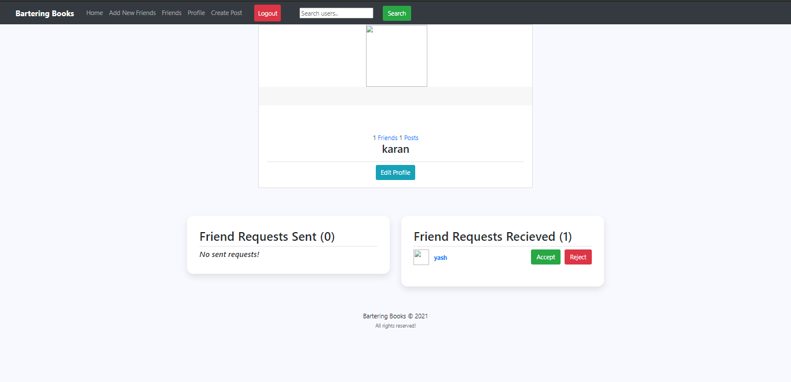

Fig 4.14: Received Friend request

This picture shows the friend request which is received by a user and user could either accept the request or reject it.

* **Friends List**

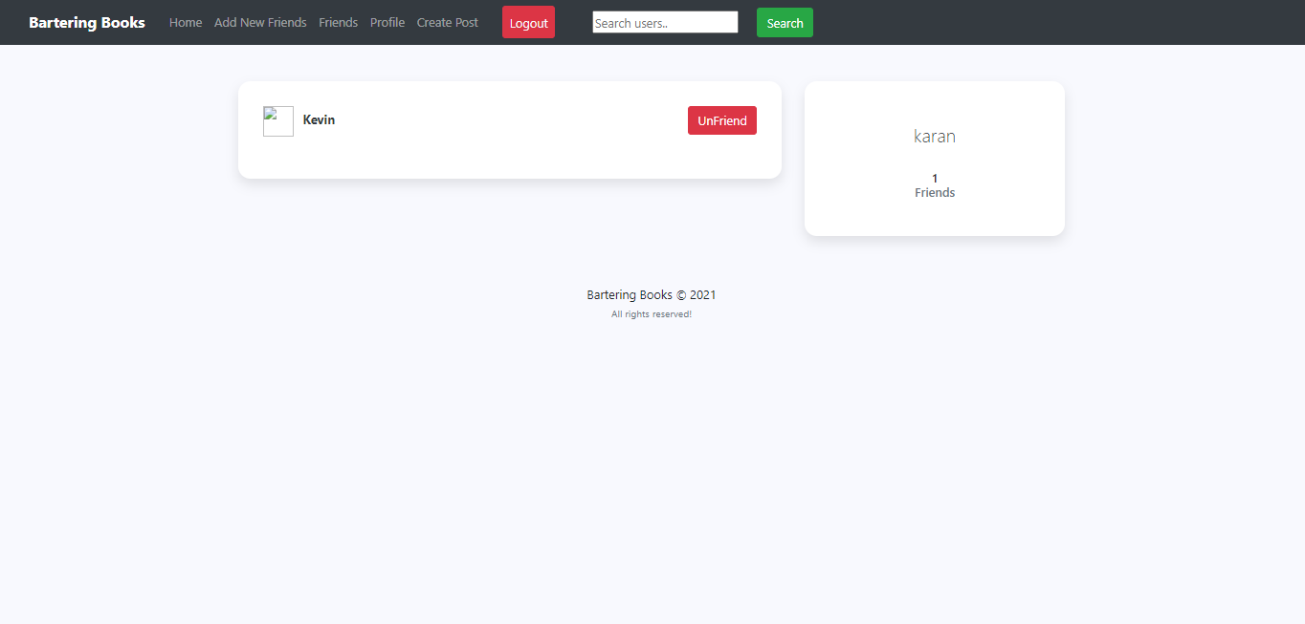

Fig 4.15: Friend List

Here is the friend list of a user. This is where all the friends of a particular is displayed.

* **Inbox**

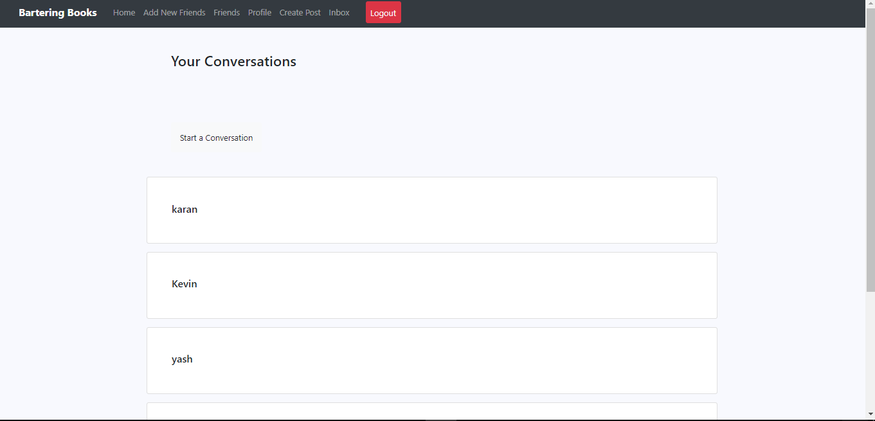

Fig 4.16: Selecting a user for a conversation

Here, user will select the user with whom he/she wants to communicate.

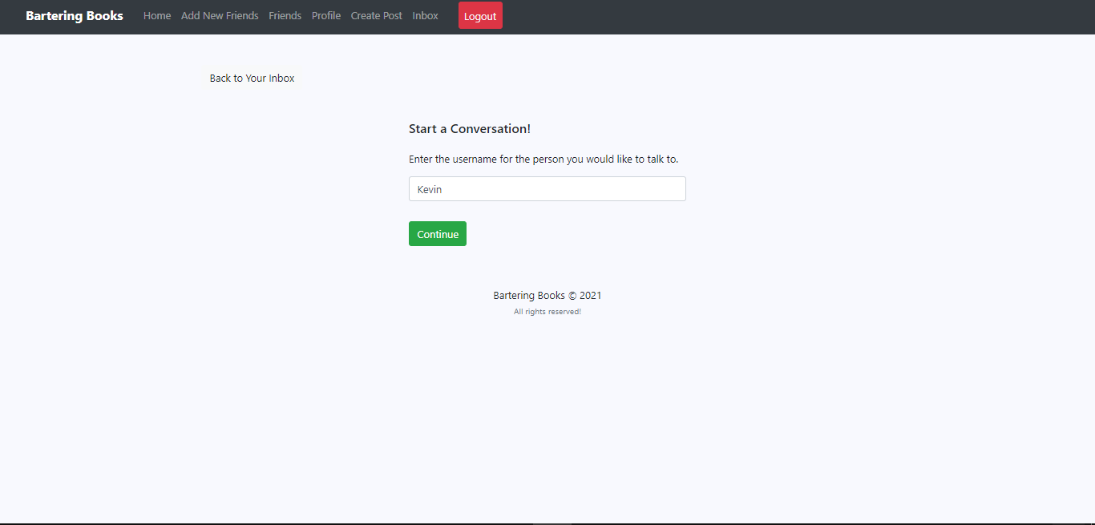

Fig 4.17: Begin the conversation

After selecting the user with whom one wants to begin a conversation one can continue and can communicate.

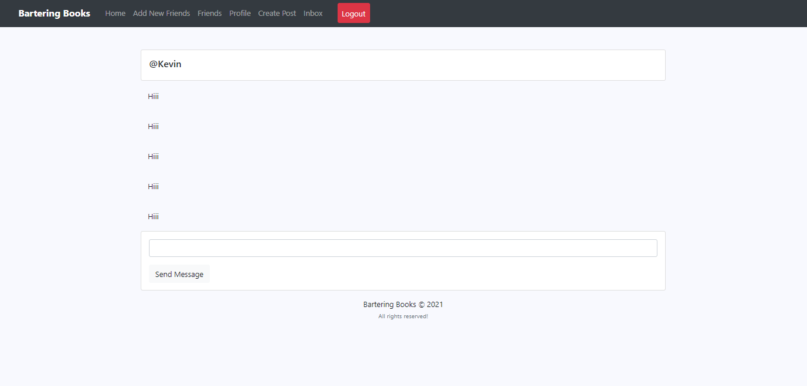

Fig 4.18: Inbox

The above picture shows the inbox section where 2 users can make a conversation with one another.

* **Admin Panel Login**

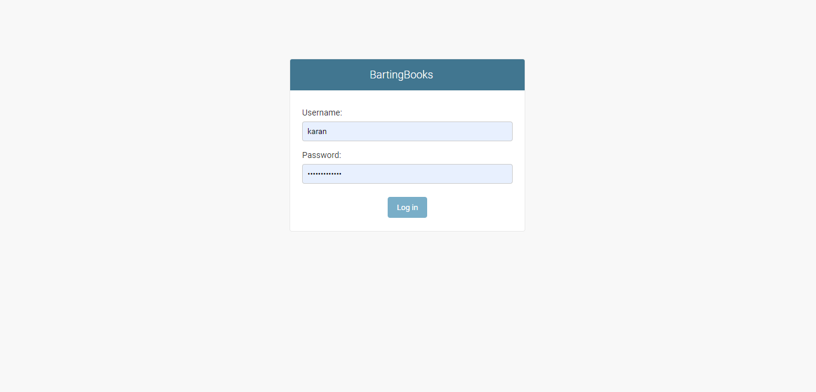

Fig 4.19: Admin Panel Login

The Admin will login through this page by entering his/her login credentials.

* **Admin Panel**

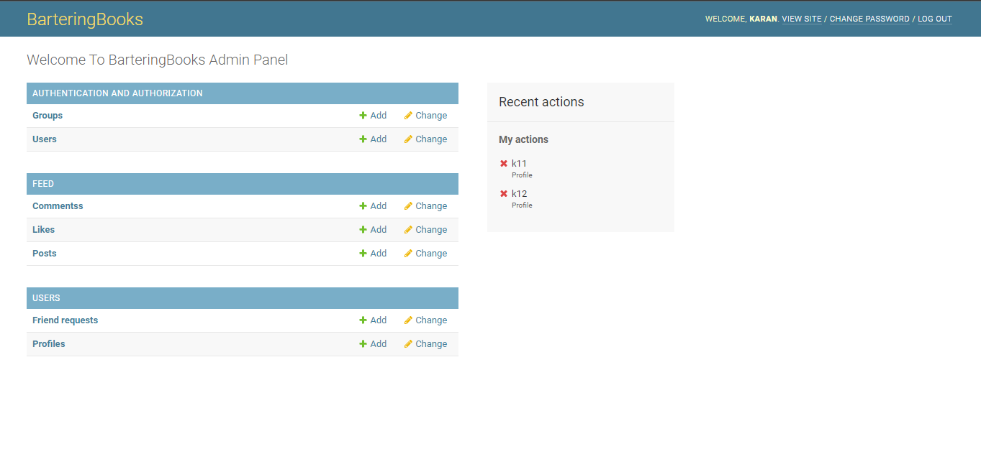

Fig 4.20; Admin Panel

This is the layout of admin panel which can only be accessed by Admin.

* **Admin Profiles**

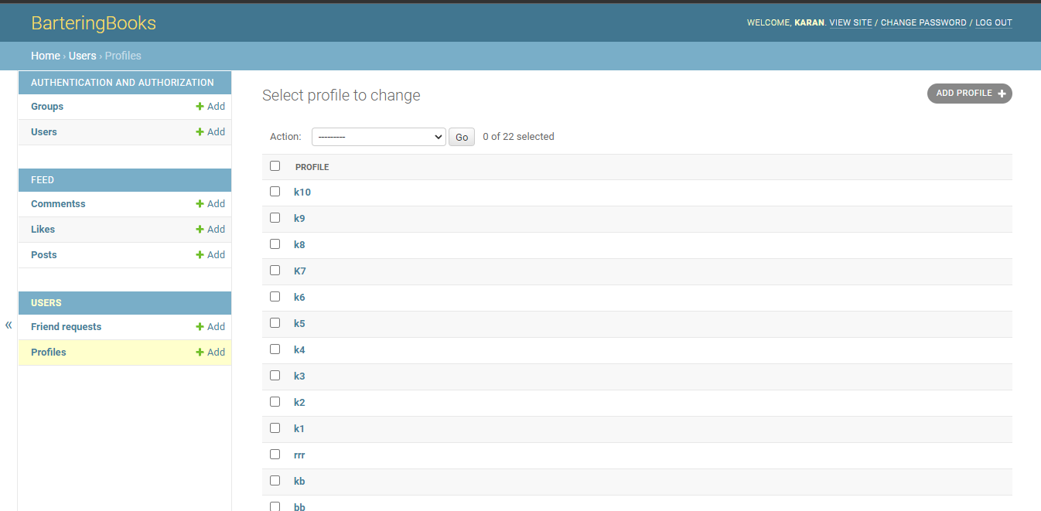

Fig 4.21: Admin Profiles

There can be more than one Admin so there can be more than one admin profiles as shown above.

* **Users**

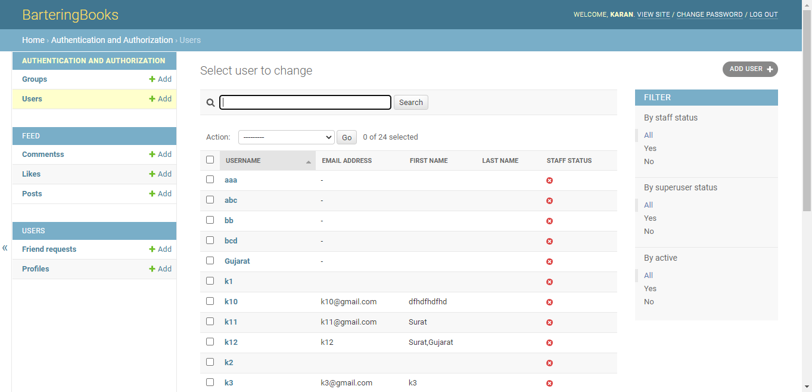

Fig 4.22: Users

All the users are visible to Admin who can remove users,

* **User Likes**

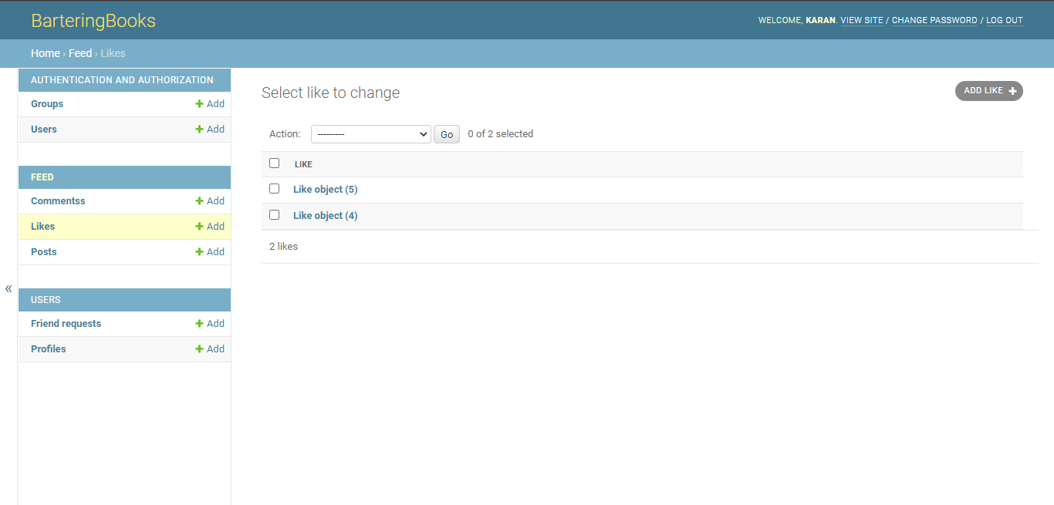

Fig 4.23.1: User Likes

Admin can manage likes on the post of the users.

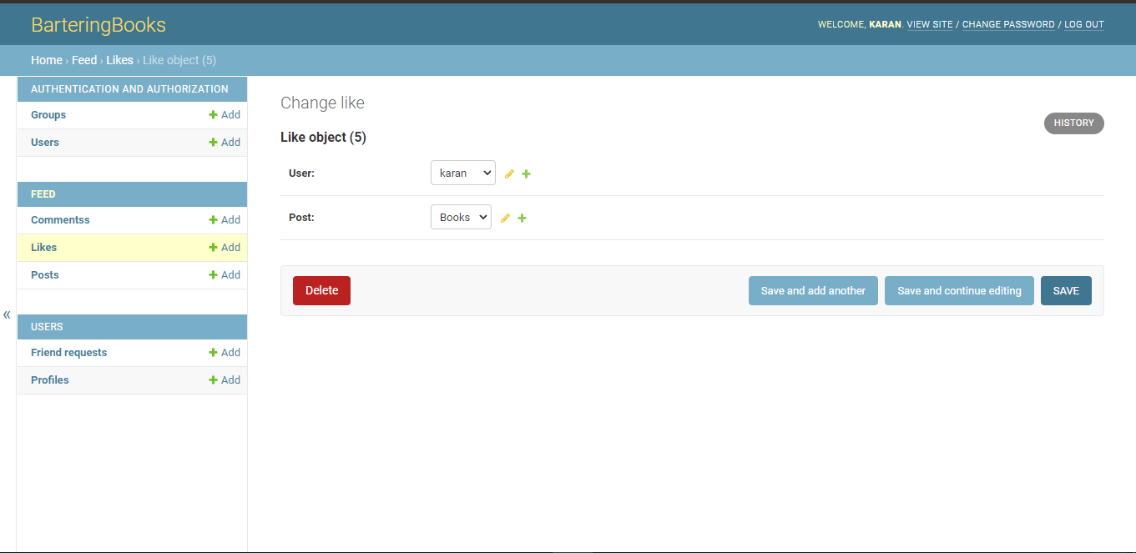

Fig 4.23.2: Removing User Likes

Admin can remove the likes on the user’s post.

* **User Comments**

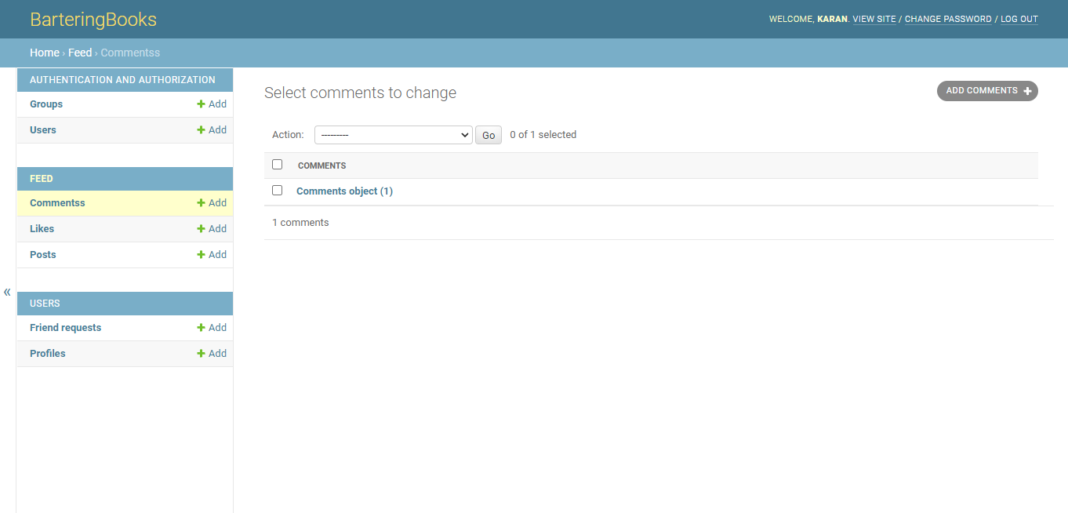

Fig 4.24.1: User Comments

User comments are visible to the admin in their admin panel.

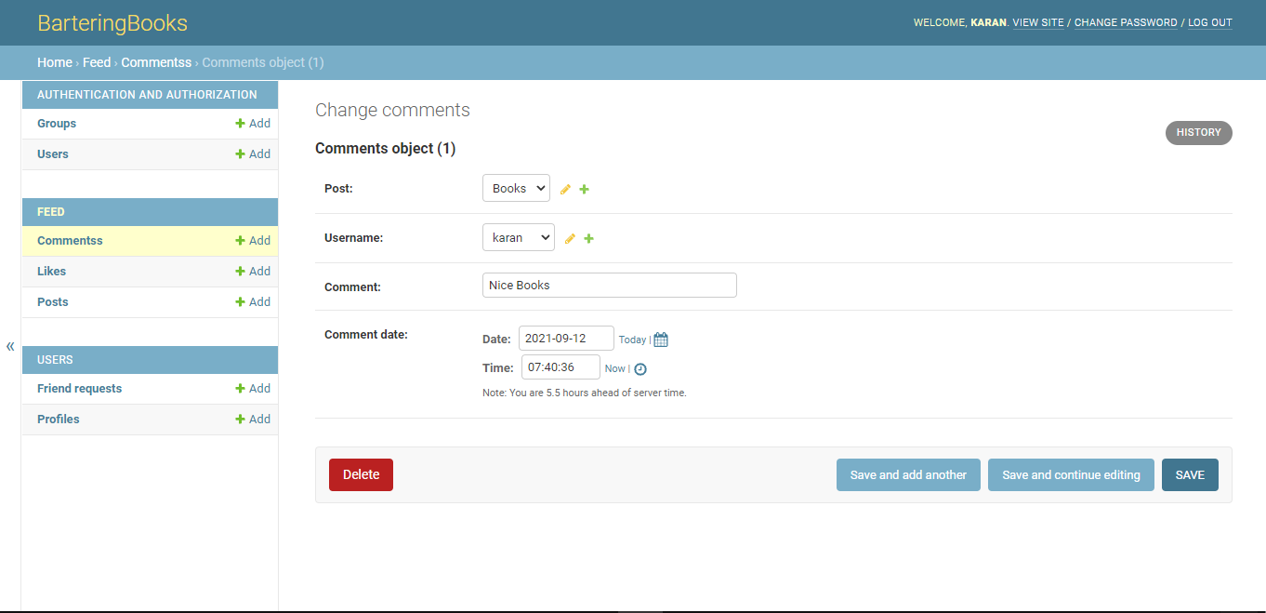

Fig 4.24.2: Removing Comments

Admin has right to remove the comments from the post of the users and can do so as shown above.

* **User Post**

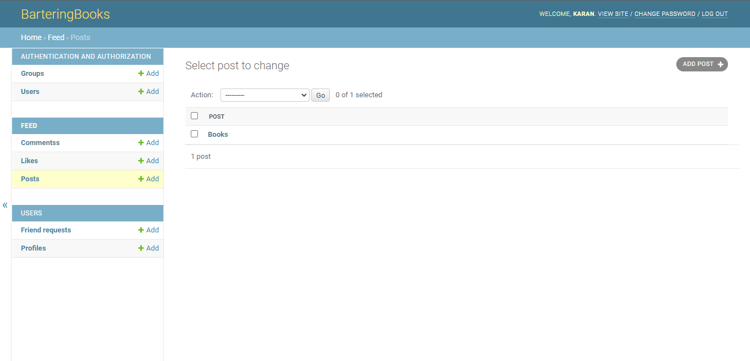

Fig 4.25.1: User Post

All the posts uploaded by the user is visible in the admin panel that is managed by admin.

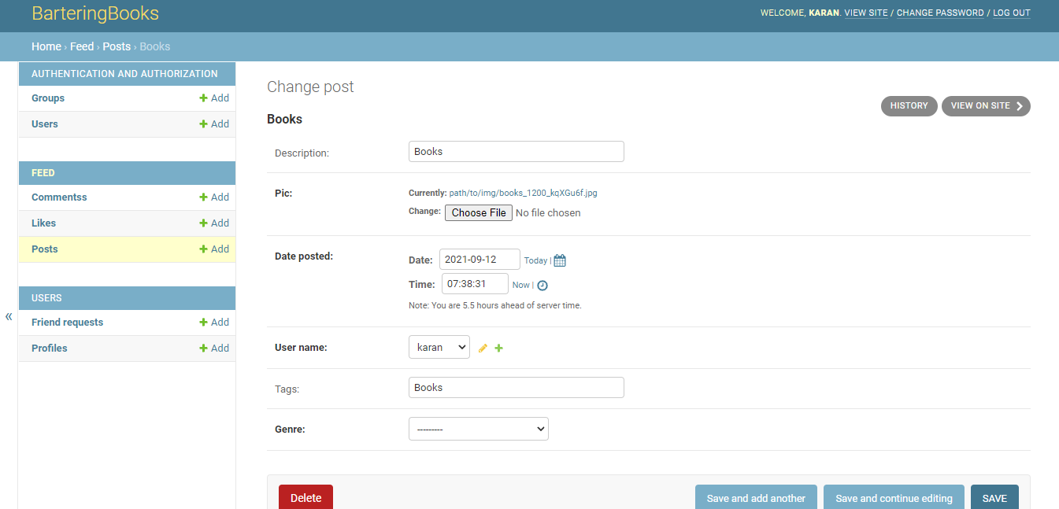

Fig 4.25.2: Removing User’s Post

Admin can remove the post uploaded by the user if found inappropriate as shown in above picture.

## 4.2 Test Cases

Sample test cases are given as below:

|  |  |  |  |  |  |
| --- | --- | --- | --- | --- | --- |
| **TestID** | **Case** | **Test Data** | **ExpectedResult** | **ActualResult** | **Pass/Fail** |
| 1 | Login | * Internet   Connectivity   * Login ID * Password | If Login ID & password is empty or invalid and No Internet connectivity then display Error message otherwise Login successfully | If Login ID & password is empty or invalid and No Internet  connectivity  then display  Error message. | Pass |
| 2 | Home  (Without login) | Swipe down  For | First time  Synchronization | First time  Synchronized. | Pass |
|  |  | Synchronization | When swipe down, post uploaded by users will refresh | When swipe down, post uploaded by users will refresh |  |
| 3 | Home  (With login) | Register, login | Shows the functionalities that can be performed by users. | Shows the functionalities that can be performed by users.. | Pass |
| 4 | Profile | User’s details(name, profile photo, posts, etc) | Display’s the user details, can edit the profile, request sent details and request received details. | Display’s the user details, can edit the profile, request sent details and request received details. | Pass |
| 5 | Create Post | Enter post details  (description, picture, tags, genre) | Post is uploaded on the feed. | Post is uploaded on the feed. | Pass |
| 6 | Add Friends | Send friend request from available users | Friend added after request accepted. | Friend added after request accepted. | Pass |
| 7 | Friends | Can unfriend from existing friends. | See the list of friends and unfriend them. | See the list of friends and unfriend them. | Pass |
| 8 | Inbox | Send message | Send message to another user. | Send message to another user. | pass |
| 5 | Logout | Select  Logout | User should logout and redirected to login again message. | User should logout and redirected to login again message. | Pass |
| 6 | Exit | Select Exit | Application should be closed. | Application is closed. | Pass |

# 

# Conclusion and Future Scope

**Conclusion:** To summarize, all the work done by our side is shown which includes the working of the website, navigations, functional requirements, non-functional requirements, hardware requirements as well as software requirements. This project will surely help to the intended audience.

**Future Work:** In the future we will be working on the left out modules and on some of the more advanced features which can provide more flexibility and easiness to the users.

# References

**Web references**

1. <https://docs.djangoproject.com/en/3.2/>
2. <https://www.bookcrossing.com/>
3. <https://ndl.iitkgp.ac.in/>
4. https://www.mypustak.com/